

R.D & S.H NATIONAL COLLEGE & S.W.A

Science College

Journal Practical

Of INFORMATION RETRIEVAL

PRAVALITH RAO

Roll No:CS21013

Seat No:1108280

TYBSC(Computer Science)

**R.D. & S.H. National College &S.W.A. Science College**



**Bandra, Mumbai *–* 400050**

**Department of Computer Science**

**CERTIFICATE**

This is to certify that **Mr. PRAVALITH RAO** Roll No./Seat No. **CS21013 / 1108280** of **TYBsc CS** Class has satisfactorily completed Practicals, in the subject of **Information Retrieval** , during the **Semester VI** of academic year **2023 *–* 2024**

**Faculty Incharge Co-ordinator,**

**Department Computer Science**

**Signature of Examiner**

**INDEX**

|  |  |  |  |  |
| --- | --- | --- | --- | --- |
| **Sr. No.** | **Title** | **Page Nos** | **Date** | **Signature** |
| 1 | Document Indexing and Retrieval |  |  |  |
| 2 | Retrieval Models  (Boolean Model and Vector Space Model) |  |  |  |
| 3 | Spelling Correction in IR Systems |  |  |  |
| 4 | Evaluation Metrics for IR Systems |  |  |  |
| 5 | Text Categorization  (using Naive Bayes or Support Vector Machines) |  |  |  |
| 6 | Clustering for Information Retrieval (K-means clustering) |  |  |  |
| 7 | Web Crawling and Indexing |  |  |  |
| 8 | Link Analysis and PageRank (implementation of PageRank algorithm) |  |  |  |
| 10 | Text summarization algorithm implementation |  |  |  |

**Practical No. 1**

**Title: Document Indexing and Retrieval**

**Aim: To implement a basic document retrieval system using an inverted index and use it to efficiently search for documents containing specific terms.**

Given a set of documents, build an inverted index data structure that maps each unique term to the documents in which it appears. The program should allow users to input a query consisting of one or more terms and retrieve the documents that contain all the terms in the query. The program should provide users as output, the relevant documents based on the terms present in their query.

**Program**

from nltk.corpus import stopwords

from nltk.tokenize import word_tokenize

# Define the documents documents = {

"Document 1": "The quick brown fox jumped over the lazy dog", "Document 2": "The lazy dog slept in the sun",

"Document 3": "The quick brown fox and the lazy dog are friends", "Document 4": "The lazy cat watched the lazy dog",

"Document 5": "The quick brown fox ran through the forest"

}

# Step 0: Import NLTK stopwords stopWords = stopwords.words('english')

# Step 1: Tokenize the documents tokens = {}

for doc_id, doc_text in documents.items(): tokens[doc_id] = set(word_tokenize(doc_text.lower()))

# Step 2: Build the inverted index inverted_index = {}

for doc_id, doc_tokens in tokens.items(): for term in doc_tokens:

if term not in stopWords:

if term not in inverted_index: inverted_index[term] = set()

inverted_index[term].add(doc_id)

# Step 3: Document Retrieval System def search_documents(query):

query_terms = set(word_tokenize(query.lower())) - set(stopWords) matching_documents = set()

for term in query_terms:

term_documents = inverted_index.get(term, set()) if not matching_documents:

matching_documents = term_documents else:

matching_documents = matching_documents.intersection(term_documents)

return matching_documents

# Step 4: User Input and Query Processing

user_query = input("Enter your query").strip().lower()

matching_docs = search_documents(user_query) if matching_docs:

print(f"\nDocuments containing the terms '{user_query}':

{matching_docs}")

for doc_id in matching_docs:

print(f"{doc_id}: {documents[doc_id]}")

else:

print(f"\nNo documents found for the query '{user_query}'.")

**Output:**

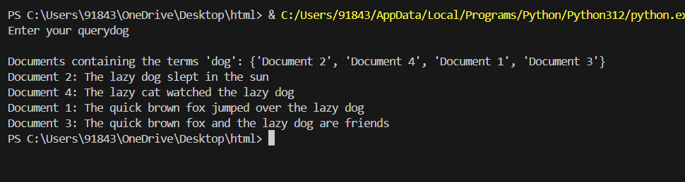

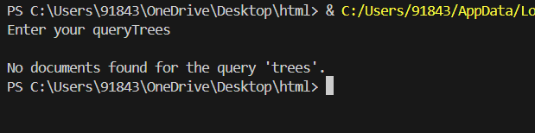

**Practical No. 2**

**Title: Retrieval Models (Boolean Model and Vector Space Model) Aim:**

1. **to implement a simple Boolean retrieval system using an inverted index.**
2. **to implement document retrieval using the TF-IDF (Term Frequency-Inverse Document Frequency) vectorization technique and cosine similarity.**

Develop a basic information retrieval system capable of handling Boolean queries over a collection of text documents. The system should provide functionality for performing Boolean AND, OR, and NOT operations on terms extracted from the documents. The goal is to efficiently retrieve relevant documents that match the user’s query based on the presence or absence of specific terms.

**Program**

from nltk.tokenize import word_tokenize from nltk.corpus import stopwords

# Example documents documents = [

"The quick brown fox jumped over the lazy dog", "The lazy dog slept in the sun",

"The quick brown dog chased the squirrel up the tree", "The sun shines bright in the sky",

"The brown fox is quick and agile"

]

# Tokenize and create the inverted index def build_inverted_index(documents):

inverted_index = {}

stop_words = set(stopwords.words('english'))

for doc_id, document in enumerate(documents, start=1):

words = set(word_tokenize(document.lower())) - stop_words for word in words:

if word not in inverted_index: inverted_index[word] = []

inverted_index[word].append(doc_id) return inverted_index

# Boolean AND operation using inverted index def boolean_and(operands, index, total_docs):

if not operands:

return list(range(1, total_docs + 1))

result = set(index.get(operands[0], set())) for term in operands[1:]:

result = result.intersection(index.get(term, set())) return list(result)

# Boolean OR operation using inverted index def boolean_or(operands, index):

result = set()

for term in operands:

result = result.union(index.get(term, set())) return list(result)

# Boolean NOT operation using inverted index def boolean_not(operand, index, total_docs):

operand_set = set(index.get(operand, set())) all_docs_set = set(range(1, total_docs + 1))

not_result = all_docs_set.difference(operand_set) return list(not_result)

# Tokenize the user query and perform boolean operation based on the input def perform_boolean_operation(query, inverted_index, total_docs):

query_terms = word_tokenize(query.lower())

if 'and' in query_terms:

operands = query.split(' AND ')

query_result = boolean_and(operands, inverted_index, total_docs) elif 'or' in query_terms:

operands = query.split(' OR ')

query_result = boolean_or(operands, inverted_index) elif 'not' in query_terms:

operand = query.split('NOT ')[1]

query_result = boolean_not(operand, inverted_index, total_docs) else:

# Default to OR operation if no operator is specified operands = query_terms

query_result = boolean_or(operands, inverted_index) print(operands)

return query_result

# Example usage

inverted_index = build_inverted_index(documents) total_docs = len(documents)

# Take query input from the user

query = input("Enter your boolean query: ")

# Perform boolean operation based on the user query

query_result = perform_boolean_operation(query, inverted_index, total_docs) print(f"Documents matching the query '{query}': {query_result}")

**Output:**

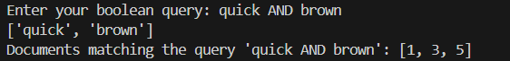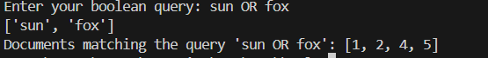

Given a query and a corpus of text documents, to rank the documents based on their similarity to the query. The relevance of a document should be determined by its similarity to the query, computed using the cosine similarity metric.

**Program**

from sklearn.feature_extraction.text import TfidfVectorizer from sklearn.metrics.pairwise import cosine_similarity from nltk.corpus import stopwords

from nltk.tokenize import word_tokenize

# Example documents documents = [

"The quick brown fox jumped over the lazy dog", "The lazy dog slept in the sun",

"The quick brown dog chased the squirrel up the tree", "The sun shines bright in the sky",

"A brown fox is quick and agile", "The lazy cat slept on the windowsill"

]

# Take query input from the user query = input("Enter your query: ")

# Tokenize the documents and query stop_words = set(stopwords.words('english'))

tokenized_documents = [" ".join([word for word in word_tokenize(doc.lower()) if word.isalnum() and word not in stop_words]) for doc in documents] tokenized_query = " ".join([word for word in word_tokenize(query.lower()) if word.isalnum() and word not in stop_words])

# TF-IDF Vectorization vectorizer = TfidfVectorizer()

tfidf_matrix = vectorizer.fit_transform(tokenized_documents) query_vector = vectorizer.transform([tokenized_query])

# Calculate cosine similarity between the query vector and document vectors cosine_similarities = cosine_similarity(query_vector, tfidf_matrix).flatten()

# Display the cosine similarities print("Cosine Similarities:")

for i, similarity in enumerate(cosine_similarities, start=1): print(f"Document {i}: {similarity}")

# Rank documents based on cosine similarity ranked_indices = cosine_similarities.argsort()[::-1]

# Display the ranked documents

print("\nRanked Documents based on Similarity:") for index in ranked_indices:

print(f"Document {index + 1}: {documents[index]} (Similarity Score:

{cosine_similarities[index]})")

**Output:**

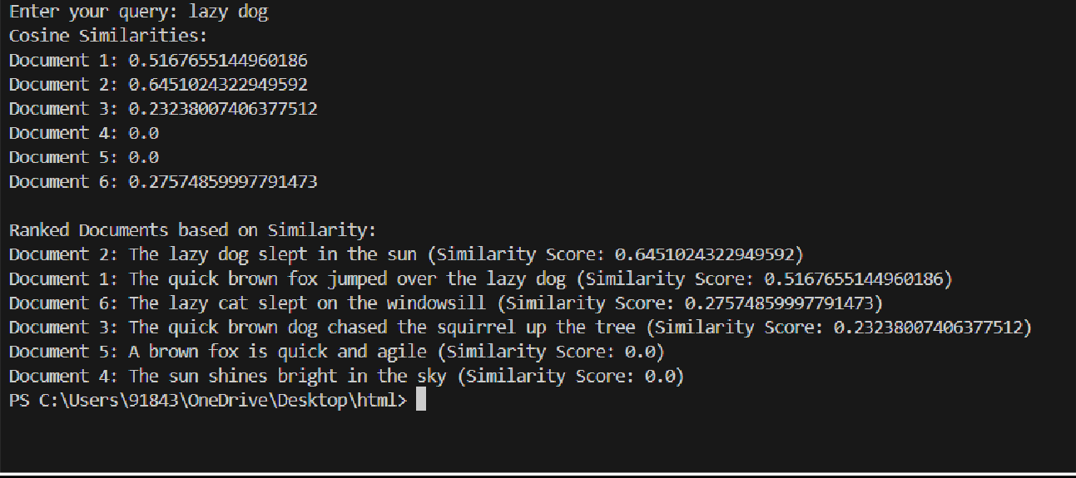

**Practical No. 3**

**Title: Spelling Correction in IR Systems**

**Aim: To implement an information retrieval system that corrects spelling using a spell-correcting algorithm (Levenshtein distance)**

Develop a program that can efficiently correct misspelled words in a user query to improve the accuracy of information retrieval. Given a set of documents and a user query containing potentially misspelled words, the program aims to identify and correct these misspellings using the Levenshtein distance algorithm.

**Program**

import numpy as np import nltk

from nltk.corpus import words

# Load the NLTK words corpus nltk.download('words') nltk_words = set(words.words())

# Spelling correction function

def levenshtein_distance(word1, word2): len1, len2 = len(word1), len(word2)

distances = np.zeros((len1 + 1, len2 + 1), dtype=int) for i in range(len1 + 1):

distances[i, 0] = i for j in range(len2 + 1):

distances[0, j] = j

for i in range(1, len1 + 1): for j in range(1, len2 + 1):

cost = 0 if word1[i - 1] == word2[j - 1] else 1 distances[i, j] = min(

distances[i - 1, j] + 1,

distances[i, j - 1] + 1, distances[i - 1, j - 1] + cost

)

return distances[len1, len2]

def correct_spelling(input_word, candidate_words): min_distance = float('inf')

corrected_word = input_word

for candidate in candidate_words:

distance = levenshtein_distance(input_word, candidate) if distance < min_distance:

min_distance = distance corrected_word = candidate

return corrected_word

# Information retrieval function def search(query, dictionary):

# Split the query into individual words query_terms = query.split()

# Spell-correct each query term

corrected_query_terms = [correct_spelling(term, dictionary) for term in query_terms]

#Return the corrected query terms return corrected_query_terms

# Example usage

user_query = input("Enter your query: ") corrected_query = search(user_query, nltk_words)

print(f"User Query: {user_query}")

print(f"Corrected Query: {' '.join(corrected_query)}")

**Output:**

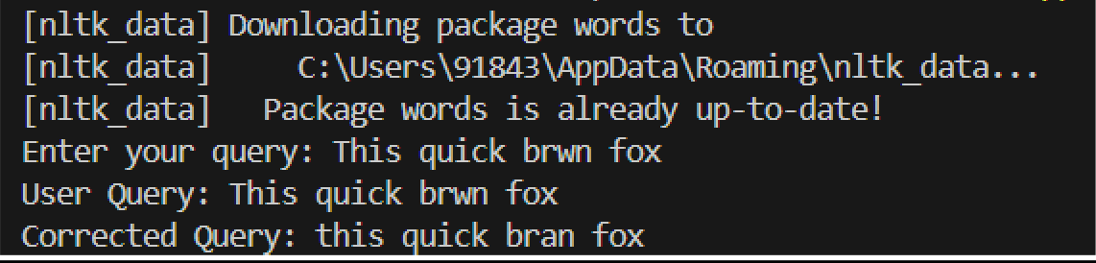

**Practical No. 4**

**Title: Evaluation Metrics for IR Systems**

**Aim: To calculate precision, recall, and F-measure**

Design a program to calculate precision, recall, and F1-score based on the user-provided values of true positives (TP), false positives (FP), and false negatives (FN). The program should prompt the user to input the number of true positives (TP), false positives (FP), and false negatives (FN) and Calculate precision, recall, and F1-score using the provided inputs.

**Program**

def calculate_precision_recall_f1(tp, fp, fn): precision = tp / (tp + fp) if (tp + fp) > 0 else 0 recall = tp / (tp + fn) if (tp + fn) > 0 else 0

f1 = (2 * precision * recall) / (precision + recall) if (precision + recall) > 0 else 0

return precision, recall, f1

# User input for TP, FP, FN

tp = int(input("Enter the number of True Positives (TP): ")) fp = int(input("Enter the number of False Positives (FP): ")) fn = int(input("Enter the number of False Negatives (FN): "))

# Calculate precision, recall, and F1-score

precision, recall, f1 = calculate_precision_recall_f1(tp, fp, fn)

# Print the results print(f"Precision: {precision:.2f}") print(f"Recall: {recall:.2f}")

print(f"F1-score: {f1:.2f}")

**Output:**

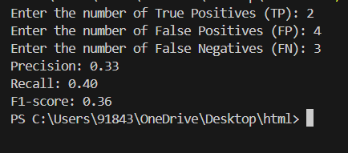

Calculate the precision, recall, and F-measure metrics for an information retrieval system based on the number of true positives (TP), false positives (FP), and false negatives (FN) obtained from comparing two sets of retrieved documents and relevant documents.

**Program**

def calculate_metrics(retrieved_set, relevant_set): true_positive = len(retrieved_set.intersection(relevant_set)) false_positive = len(retrieved_set.difference(relevant_set)) false_negative = len(relevant_set.difference(retrieved_set))

print("True Positive: ", true_positive, "\nFalse Positive: ", false_positive,

"\nFalse Negative: ", false_negative, "\n")

precision = true_positive / (true_positive + false_positive) if (true_positive + false_positive) > 0 else 0

recall = true_positive / (true_positive + false_negative) if (true_positive + false_negative) > 0 else 0

f_measure = 2 * precision * recall / (precision + recall) if (precision

+ recall) > 0 else 0

return precision, recall, f_measure # Create an exhaustive list of terms

all_terms = ["apple", "banana", "orange", "grape", "melon","papaya"] retrieved=["banana", "orange","papaya"] relevant=["orange","papaya","melom"]

# Example usage:

retrieved_set = set(retrieved) # Predicted set

relevant_set = set(relevant) # Actually Needed set (Relevant)

precision, recall, f_measure = calculate_metrics(retrieved_set, relevant_set)

print(f"Precision: {precision}") print(f"Recall: {recall}") print(f"F-measure: {f_measure}")

**Output:**

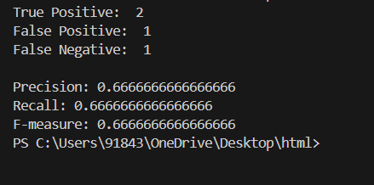

Given a set of predicted binary labels (y_pred) and their corresponding true binary labels (y_true), evaluate the performance by calculating precision, recall, f1-score and average precision of a binary classification model using standard metrics from scikit-learn module

**Program**

from sklearn.metrics import precision_recall_curve, average_precision_score, roc_curve, roc_auc_score

# Example data

y_true = [0, 1, 1, 0, 1]

y_scores = [0.1, 0.8, 0.6, 0.3, 0.9] # Predicted scores (probability of positive class)

# Calculate precision-recall curve

precision, recall, _ = precision_recall_curve(y_true, y_scores)

# Calculate average precision

avg_precision = average_precision_score(y_true, y_scores)

# Print the results print("Precision-Recall Curve:") print("Precision:", precision) print("Recall:", recall)

print("Average Precision:", avg_precision)

**Output:**

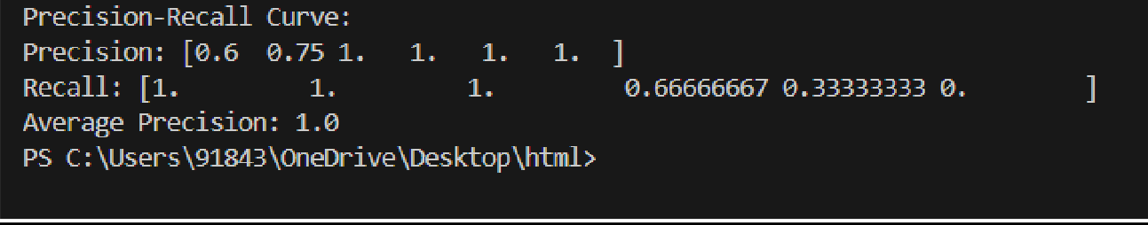

**Practical No. 5**

**Title: Text Categorization (using Naive Bayes or Support Vector Machines)**

**Aim: To construct a text classification system using the Naive Bayes or SVM classifier.**

Given a dataset of 20_newsgroups, build a classification model using Naïve Bayes classifier that can accurately classify each review as either positive or negative.

**Program**

from sklearn.feature_extraction.text import TfidfVectorizer from sklearn.naive_bayes import MultinomialNB

from sklearn.model_selection import train_test_split

from sklearn.metrics import accuracy_score, classification_report, confusion_matrix

from sklearn.datasets import fetch_20newsgroups

# Load the 20 newsgroups dataset

newsgroups = fetch_20newsgroups(subset='all', remove=('headers', 'footers', 'quotes'))

# Split the dataset into training and testing sets

X_train, X_test, y_train, y_test = train_test_split(newsgroups.data, newsgroups.target, test_size=0.2, random_state=42)

# Vectorize the text data using TF-IDF vectorizer = TfidfVectorizer(max_features=10000) X_train_tfidf = vectorizer.fit_transform(X_train) X_test_tfidf = vectorizer.transform(X_test)

# Train a Multinomial Naive Bayes classifier classifier = MultinomialNB() classifier.fit(X_train_tfidf, y_train)

# Make predictions on the test set y_pred = classifier.predict(X_test_tfidf)

# Calculate accuracy

accuracy = accuracy_score(y_test, y_pred) print(f"Accuracy: {accuracy:.2f}")

# Display classification report print("\nClassification Report:") print(classification_report(y_test, y_pred, target_names=newsgroups.target_names))

# Display confusion matrix print("\nConfusion Matrix:") print(confusion_matrix(y_test, y_pred))

**Output:**

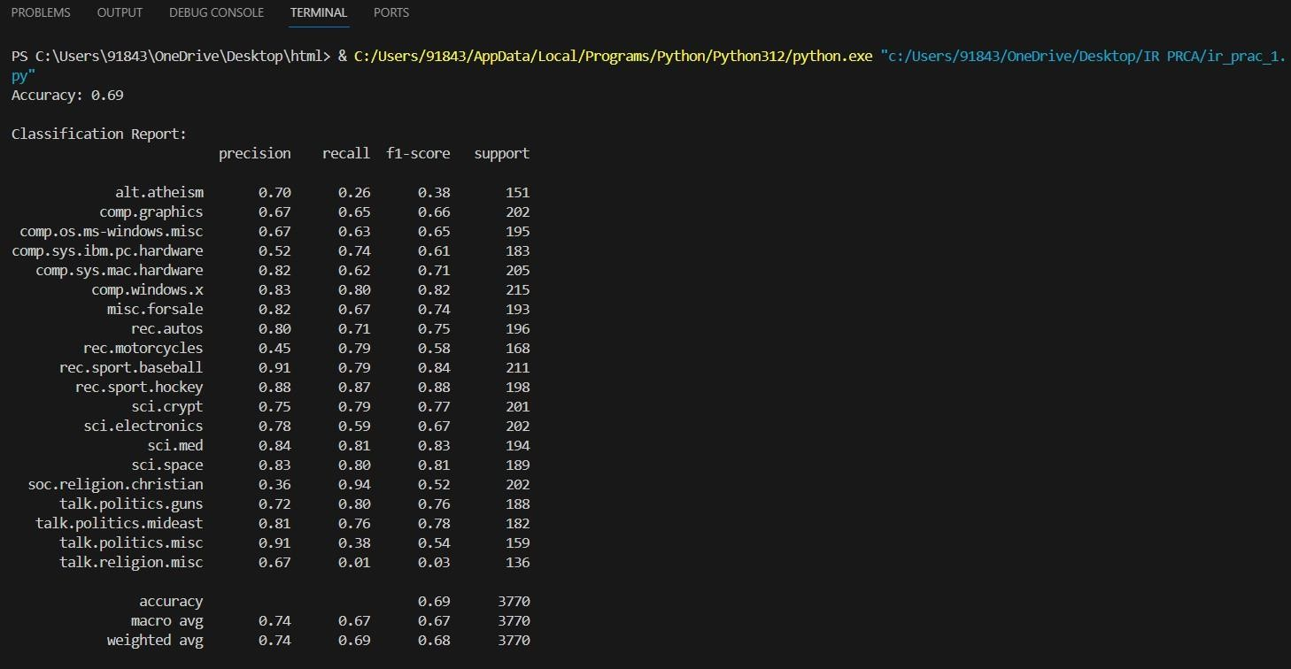

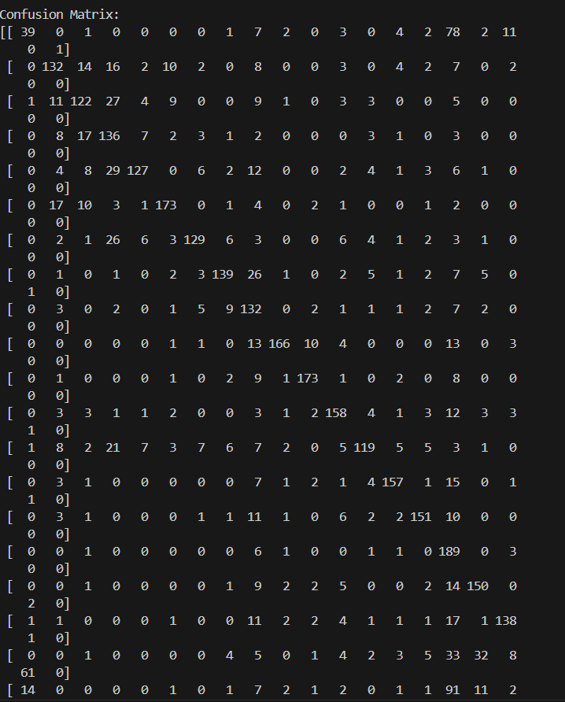

Given a dataset of 20_newsgroups, build a classification model using SVM classifier that can accurately classify documents into categories like “alt.atheism,” “soc.religion.christian,” “comp.graphics,” or “sci.med,”

**Program**

from sklearn.datasets import fetch_20newsgroups

from sklearn.feature_extraction.text import TfidfVectorizer from sklearn.model_selection import train_test_split

from sklearn.svm import SVC

from sklearn.metrics import accuracy_score, classification_report

# Load the 20 Newsgroups dataset

categories = ['alt.atheism', 'soc.religion.christian', 'comp.graphics', 'sci.med']

newsgroups_train = fetch_20newsgroups(subset='train', categories=categories) newsgroups_test = fetch_20newsgroups(subset='test', categories=categories)

# Extract features from text using TF-IDF Vectorizer vectorizer = TfidfVectorizer()

X_train = vectorizer.fit_transform(newsgroups_train.data) X_test = vectorizer.transform(newsgroups_test.data) y_train = newsgroups_train.target

y_test = newsgroups_test.target

# Split the dataset into training and testing sets

X_train, X_test, y_train, y_test = train_test_split(X_train, y_train, test_size=0.2, random_state=42)

# Train the SVM classifier svm_classifier = SVC(kernel='linear') svm_classifier.fit(X_train, y_train)

# Make predictions on the testing set predictions = svm_classifier.predict(X_test)

# Evaluate the model

accuracy = accuracy_score(y_test, predictions) print("Accuracy:", accuracy) print("Classification Report:") print(classification_report(y_test, predictions, target_names=newsgroups_test.target_names))

**Output:**

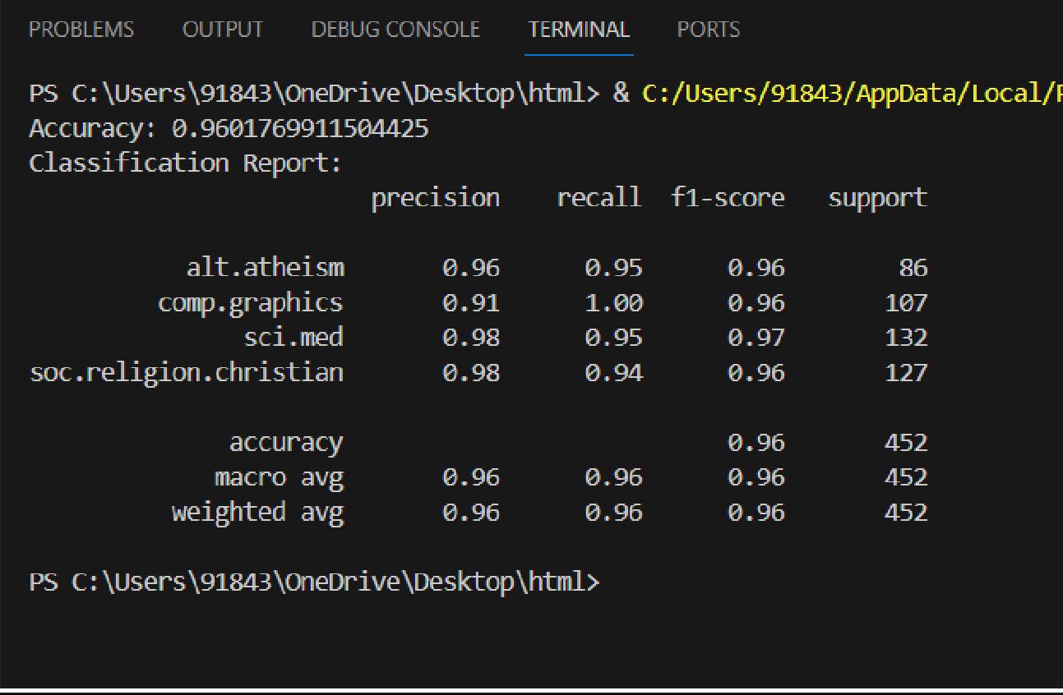

**Practical No. 6**

**Title: Clustering for Information Retrieval (K-means clustering)**

**Aim: To perform text clustering on the 20 Newsgroups dataset using the K-means algorithm and evaluate the quality of clustering results.**

Given a collection of text documents, group similar documents into clusters using the K-means clustering algorithm.

**Program**

from sklearn.feature_extraction.text import TfidfVectorizer from sklearn.cluster import KMeans

from sklearn.feature_extraction.text import TfidfVectorizer from sklearn.cluster import KMeans

documents = [

"Cats are known for their agility and grace", # cat doc1 "Dogs are often called ‘man’s best friend’.", # dog doc1

"Some dogs are trained to assist people with disabilities.", # dog doc2

"The sun rises in the east and sets in the west.", # sun doc1 "Many cats enjoy climbing trees and chasing toys.", # cat doc2

"Birds are fascinating creatures that can fly in the sky.", # bird doc1

"Fish live in water and breathe through gills.", # fish doc1 "Reptiles are cold-blooded animals with scales or plates.", # reptile

doc1

]

"Owls are nocturnal birds of prey that hunt at night." # bird doc2

# Create a TfidfVectorizer object

vectorizer = TfidfVectorizer(stop_words='english')

# Learn vocabulary and idf from training set.

X = vectorizer.fit_transform(documents)

# Perform k-means clustering

kmeans = KMeans(n_clusters=3, random_state=0).fit(X)

# Print cluster labels for each document print(kmeans.labels_)

**Output:**

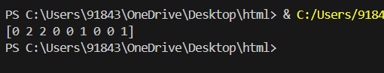

Given a collection of text documents from the 20 Newsgroups dataset, group similar documents into clusters using the K-means clustering algorithm.

**Program**

from sklearn.feature_extraction.text import TfidfVectorizer from sklearn.cluster import KMeans

from sklearn import metrics

from sklearn.datasets import fetch_20newsgroups

# Step 1: Load and Preprocess the Data

dataset = fetch_20newsgroups(subset='all', shuffle=True, random_state=42) documents = dataset.data

# Step 2: Feature Extraction

vectorizer = TfidfVectorizer(stop_words='english')

X = vectorizer.fit_transform(documents)

# Step 3: Apply K-means Clustering num_clusters = 20 # Number of clusters

kmeans = KMeans(n_clusters=num_clusters, random_state=42) kmeans.fit(X)

# Step 4: Evaluate Clustering Results

silhouette_score = metrics.silhouette_score(X, kmeans.labels_, metric='euclidean')

ari_score = metrics.adjusted_rand_score(dataset.target, kmeans.labels_)

print("Silhouette Score:", silhouette_score) print("Adjusted Rand Index (ARI):", ari_score)

**Output:**

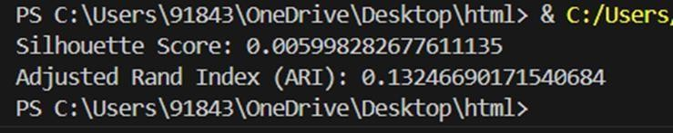

Given a collection of text documents, group similar documents into clusters using the hierarchical clustering algorithm.

**Program**

from sklearn.feature_extraction.text import TfidfVectorizer from sklearn.cluster import AgglomerativeClustering

documents = [

"Cats are known for their agility and grace", # cat doc1 "Dogs are often called ‘man’s best friend’.", # dog doc1

"Some dogs are trained to assist people with disabilities.", # dog doc2

"The sun rises in the east and sets in the west.", # sun doc1 "Many cats enjoy climbing trees and chasing toys.", # cat doc2

"Birds are fascinating creatures that can fly in the sky.", # bird doc1

"Fish live in water and breathe through gills.", # fish doc1 "Reptiles are cold-blooded animals with scales or plates.", # reptile

doc1

]

"Owls are nocturnal birds of prey that hunt at night." # bird doc2

# Create a TfidfVectorizer object

vectorizer = TfidfVectorizer(stop_words='english')

# Learn vocabulary and idf from training set.

X = vectorizer.fit_transform(documents)

# Perform hierarchical clustering

agg_clustering = AgglomerativeClustering(n_clusters=3).fit(X.toarray())

# Print cluster labels for each document print(agg_clustering.labels_)

**Output:**

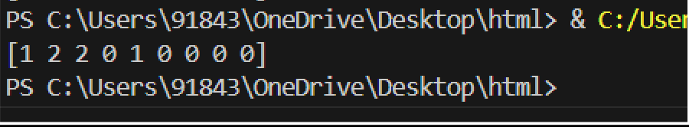

Given a collection of text documents from the 20 Newsgroups dataset, group similar documents into clusters using the hierarchial clustering algorithm.

**Program**

from sklearn.feature_extraction.text import TfidfVectorizer from sklearn.cluster import AgglomerativeClustering

from sklearn import metrics

from sklearn.datasets import fetch_20newsgroups

# Step 1: Load and Preprocess the Data

dataset = fetch_20newsgroups(subset='all', shuffle=True, random_state=42) documents = dataset.data

# Step 2: Feature Extraction

vectorizer = TfidfVectorizer(stop_words='english')

X = vectorizer.fit_transform(documents)

# Step 3: Apply Hierarchical Clustering num_clusters = 20 # Number of clusters

hierarchical_clustering = AgglomerativeClustering(n_clusters=num_clusters) hierarchical_clustering.fit(X.toarray())

# Step 4: Evaluate Clustering Results silhouette_score = metrics.silhouette_score(X, hierarchical_clustering.labels_, metric='euclidean')

ari_score = metrics.adjusted_rand_score(dataset.target, hierarchical_clustering.labels_)

print("Silhouette Score:", silhouette_score) print("Adjusted Rand Index (ARI):", ari_score)

**Output:**

**Practical No. 7**

**Title: Web Crawling and Indexing**

**Aim: Develop a web crawler to fetch and index web pages.**

**Program**

import requests

from bs4 import BeautifulSoup from urllib.parse import urljoin

from urllib.robotparser import RobotFileParser import time

def get_html(url): try:

headers = {'User-Agent': 'Mozilla/5.0 (Windows NT 10.0; Win64; x64) AppleWebKit/537.36 (KHTML, like Gecko) Chrome/58.0.3029.110 Safari/537.3'}

response = requests.get(url, headers=headers) response.raise_for_status()

return response.text

except requests.exceptions.RequestException as err: print(f"Request Error: {err}")

return None

def load_robots_txt(url): try:

robots_url = urljoin(url, '/robots.txt') robots_content = get_html(robots_url) robot_parser = RobotFileParser()

if robots_content: robot_parser.parse(robots_content.split('\n'))

return robot_parser except Exception as e:

print(f"Error loading robots.txt: {e}") return None

def extract_links(html, base_url):

soup = BeautifulSoup(html, 'html.parser')

links = [urljoin(base_url, link['href']) for link in soup.find_all('a', href=True)]

return links

def is_allowed_by_robots(robot_parser, url): return robot_parser.can_fetch('*', url)

def crawl(start_url, max_depth=3, delay=1): visited_urls = set()

robot_parser = load_robots_txt(start_url)

def recursive_crawl(url, depth):

if depth > max_depth or url in visited_urls or not is_allowed_by_robots(robot_parser, url):

return visited_urls.add(url) time.sleep(delay) html = get_html(url) if html:

print(f"Crawling {url}")

links = extract_links(html, url) for link in links:

recursive_crawl(link, depth + 1)

if not robot_parser or not is_allowed_by_robots(robot_parser, start_url):

print(f"Access to {start_url} is restricted by robots.txt.

Crawling aborted.")

return recursive_crawl(start_url, 1)

**Output:**

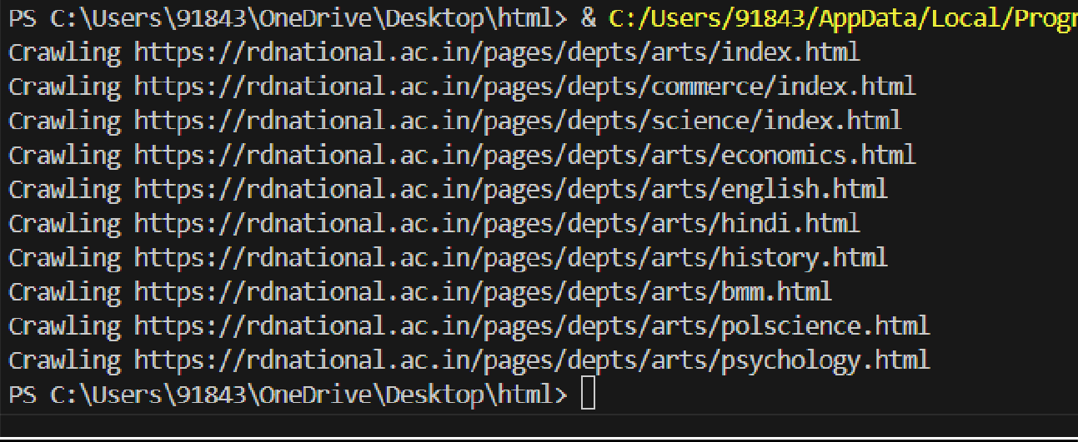

**Practical No. 8**

**Title: Link Analysis and PageRank (implementation of PageRank algorithm) Aim: Implement the PageRank algorithm to rank web pages based on link analysis.**

**Program**

import numpy as np

def page_rank(graph, damping_factor=0.85, max_iterations=100, tolerance=1e- 6):

"""

Compute PageRank scores for each node in the graph represented by an adjacency list.

Parameters:

* graph: list of lists, adjacency list representing the graph
* damping_factor: float, damping factor (default: 0.85)
* max_iterations: int, maximum number of iterations (default: 100)
* tolerance: float, tolerance for convergence (default: 1e-6)

Returns:

* pagerank_scores: numpy array, PageRank scores for each node """

num_nodes = len(graph)

page_ranks = np.ones(num_nodes) / num_nodes

for _ in range(max_iterations): prev_page_ranks = np.copy(page_ranks)

for node in range(num_nodes):

incoming_links = [i for i, v in enumerate(graph) if node in v] if not incoming_links:

continue

page_ranks[node] = (1 - damping_factor) / num_nodes + \

damping_factor * sum(prev_page_ranks[link] / len(graph[link]) for link in incoming_links)

if np.linalg.norm(page_ranks - prev_page_ranks, 2) < tolerance: break

return page_ranks # Example usage

if name == " main ":

# Define a simple directed graph as an adjacency list web_graph = [

[1, 2], # Node 0 has links to Node 1 and Node 2

[0, 2], # Node 1 has links to Node 0 and Node 2

[0, 1], # Node 2 has links to Node 0 and Node 1

[1, 2], # Node 3 has links to Node 1 and Node 2

]

# Calculate PageRank

result = page_rank(web_graph)

# Display PageRank values

for i, pr in enumerate(result): print(f"Page {i}: {pr}")

**Output:**

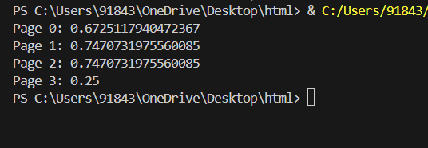

**Practical 10**

**Title:** Advanced Topics in Information Retrieval

**Aim:** Implement a text summarization algorithm (e.g., extractive or abstractive) and Build a question- answering system using techniques such as information extraction

**Program:**

from sklearn.feature_extraction.text import TfidfVectorizer from sklearn.metrics.pairwise import cosine_similarity from nltk.corpus import stopwords

from nltk.tokenize import word_tokenize import string

# Sample corpus of text data (answers) corpus = [

"Python is an interpreted, high-level, general-purpose programming language.",

"Machine learning is the scientific study of algorithms and statistical models that computer systems use to perform a specific task without using explicit instructions.",

"Natural language processing (NLP) is a subfield of linguistics, computer science, and artificial intelligence concerned with the interactions between computers and human language.",

"Deep learning is a subset of machine learning in artificial intelligence (AI) that has networks capable of learning unsupervised from data that is unstructured or unlabeled.",

"Reinforcement learning is an area of machine learning concerned with how software agents ought to take actions in an environment in order to maximize the notion of cumulative reward."

]

# Preprocess the corpus def preprocess(text):

stop_words = set(stopwords.words('english')) text = text.lower() # Convert to lowercase

text = text.translate(str.maketrans('', '', string.punctuation)) #

Remove punctuation

words = word_tokenize(text) # Tokenize words

words = [word for word in words if word not in stop_words] # Remove stopwords

return ' '.join(words)

processed_corpus = [preprocess(text) for text in corpus] # TF-IDF Vectorization

vectorizer = TfidfVectorizer()

tfidf_matrix = vectorizer.fit_transform(processed_corpus)

# User question

question = input("Enter your question: ")

# Preprocess the question processed_question = preprocess(question)

# Calculate cosine similarity between question and answers question_vector = vectorizer.transform([processed_question])

similarity_scores = cosine_similarity(question_vector, tfidf_matrix)

# Retrieve the most similar answer most_similar_index = similarity_scores.argmax() answer = corpus[most_similar_index]

print("Question:", question) print("Answer:", answer)

**output:**

